Design Document (susceptible to change)

Our core mechanic requires the player(s) to control a character through coordinated movements of the limbs. The gameplay consists of primarily ragdoll physics, turning mundane tasks into significant challenges.

The initial prototype is designed for single player gameplay, while our end goal is to deliver a game that facilitates multiplayer co-operative gameplay

The camera is located behind the player(s) to showcase

Inspiration for our concept comes from the games QWOP and Octodad which experiments with similar intricate movement mechanics. In these games, each limb is

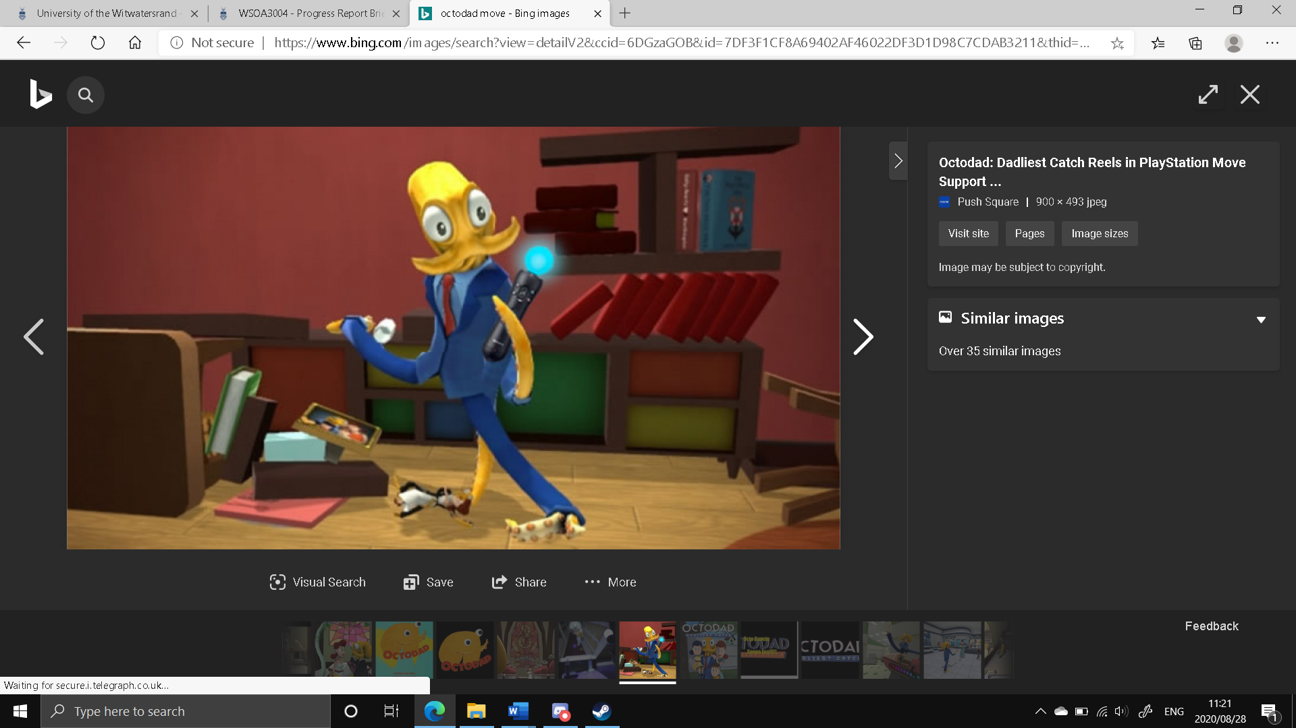

There are two different modes within *Octodad* the user can switch between to complete tasks. The first is default mode, used for moving the character throughout the game, mainly within the confines of the family house. All of his limbs are controlled independently, however, in "attack" mode, only the legs are available to the player. To move the left and right 'leg' tentacles for walking, the player must press and hold the right mouse button and push the mouse forward and release when they want to put the mouse back down and take a step.

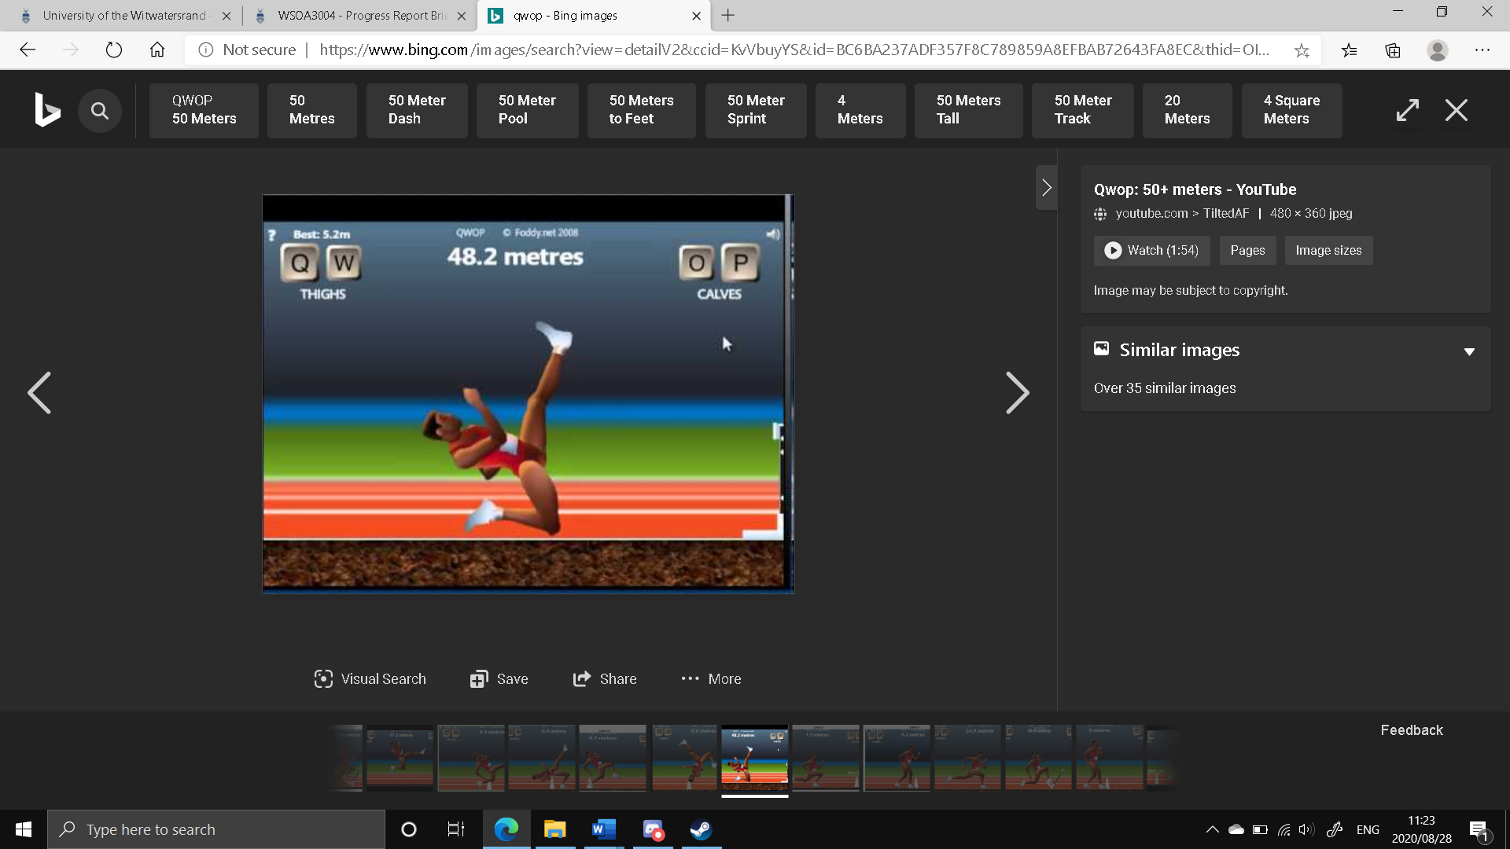

The Q and W keys each drive one of the runner's [thighs](https://en.wikipedia.org/wiki/Thigh), while the O and P keys work the runner's [calves](https://en.wikipedia.org/wiki/Calf_(leg)). The Q key drives the runner's right thigh forward and left thigh backward, and the W key also affects the thighs and does the opposite. The O and P keys work in the same way as the Q and W keys, but with the runner's calves. The actual amount of movement of a joint is affected by the resistance due to forces from gravity placed upon it.

During the development of the game, the controls schemes were a major issue of talking, with many various formats being considered, including the traditional WASD format, as well as the use of a secondary mouse, we have yet settle on how each control manipulates the character in a suitable way.